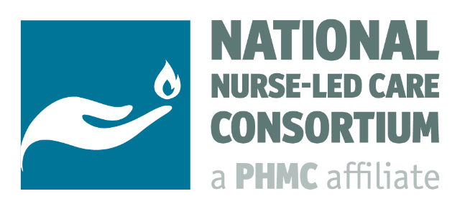

Rural Community Health
Reflections from a 2-Part Learning Collaborative Series

In Summer 2022, the National Nurse-Led Care Consortium (NNCC) conducted the Rural Community Health Learning Collaborative Series, a virtual, 2-Part training for a national nursing audience. Each 1.5 hr live session would begin with a five-minute check-in, followed by a didactic presentation and a breakout discussion in small groups. Attendees would then reconvene and share their discussion highlights. Participants were also given time to discuss any further points or ask questions.

The series focused on:
Session 1: Beyond Vaccinations and Masking: Effective Strategies for Impacting COVID-19 in Rural Communities
Session 2: Rural COVID Vaccine Hesitancy: Patient and Provider Perspectives

Featured Speakers:
- Rachel Foster MA, BSN, RN, Rural COVID-19 Program Manager, Pennsylvania Office of Rural Health
- Maureen Boardman MSN, FNP-C, FAANP, Clinical-Research Director, Dartmouth CO-OP PBRN

Session Goals
Session 1: Beyond Vaccinations and Masking: Effective Strategies for Impacting COVID-19 in Rural Communities
Rachel Foster began her presentation by sharing COVID-19 pandemic related information specific to rural Pennsylvania and the broader rural-urban divide. Considerations included reduced vaccine demand, masking, increased incidence, COVID-19 fatigue, and shifting from pandemic to endemic thinking. In her presentation, Rachel discussed areas of success within Pennsylvania’s Office of Rural Health in relation to impacting COVID-19 concerns, such as the development and impact of cross-sector COVID-19 coalitions and processes for community development. In reflecting on her work, Rachel spoke to the relevance and influence of program evaluation design regarding qualitative vs. quantitative data collection, use of rapid community assessments, message testing, and communication strategies. Some key informant interview results highlighted the pandemic worsening pre-existing health equity concerns, while staffing remains an ongoing issue. Effective strategies included a focus on infrastructure development, recovery efforts, education, and consistent, relevant outreach. The discussion also highlighted an increased need for mental health support.

Session 2: Rural COVID Vaccine Hesitancy: Patient and Provider Perspectives
Maureen Boardman centered her presentation around vaccine hesitancy in rural Northern New England with a reflection on her current research measuring patient and provider perspectives specific to COVID-19 vaccine hesitancy. Maureen briefly discussed statistics relating to vaccine uptake in rural U.S. Factors likely contributing to hesitancy include higher rates of individuals >65 years, access to healthcare remaining an ongoing challenge, the variation in views regarding the seriousness of COVID-19 infection, and vaccine hesitancy being historically higher in rural than urban areas for routine vaccines. She presented on preliminary findings from research collected across 3 Federally Qualified Health Center (FQHC) sites, in Maine, New Hampshire and Vermont surveying patients and providers on potential reasoning behind vaccination considerations. Of those initially surveyed, both short-term and long-term side effects influenced patient decision-making, while perceptions of low risk and religious belief systems were also ongoing themes. Questions also covered topics related to misinformation and provider impact.

Discussion: Emerging Themes and Participant Perspectives
In your experience, what strategies work best to impact COVID-19 in your community?
The use of social media in providing updates and informing the community of vaccine clinics
Having a rapport and trust in health care providers and other trusted individuals
Respect for all roles in health care providers
Having recognizable local leaders share their stories publicly
Focusing on resiliency and anticipating what is next in public health
Increased vaccination resulted in a decline in cases and severity of cases
Outreach efforts in multiple languages, indigenous languages, and cultural references embedded in the messages
Pandemic preparedness kits or similar are well received and helpful [Package tests with N95 mask, some sort of article that speaks to vaccination, and put it together with a card simplifying what to do if you test positive]
Encouraging people
Vaccine clinics were very successful
\

Should the COVID-19 rhetoric or interventions pivot to new or different topics and if so, why, and how?
Apply lessons learned from COVID-19 to future health issues so we are better organized and prepared
Basic science is a part of health education; Back to basics (i.e., washing hands)
What we’re doing now is not working anymore so we need to do something different
Success stories go further; if we can spread the positivity of the vaccine from that view, we might capture new audiences
Have popular local figures do radio spots or other local marketing
Shifting to general emergency responses and preparing for future events
Determine an outgoing plan for vaccinations that is more convenient for more people
Boosters and communication around them need to change
Make sure that COVID is a part of the vaccine series for children and adults for preventative care
Determine a better method to respond to health crisis in general with better resources available sooner
Addressing healthcare provider vaccine confidence with boosters
Addressing political and religious/faith-based reasoning and distrust of government

Highlighted Resources:
- Rural Response to Coronavirus Disease 2019 (COVID-19) - https://www.ruralhealthinfo.org/topics/covid-19 Saelee, R., Zell, E., Murthy, B.P., et al. Disparities in COVID-19 Vaccination Coverage Between Urban and Rural Counties – United States, December 14, 2022-January 31, 2022. MMWR Morbidity and Mortality Weekly Report 2022;71:335-340. DOI: http://dx.doi.org/10.15585/mmwr.mm7109a2

Visit www.nurseledcare.org to browse all materials from this series.
Contact communications@nncc.us for more information on our training offerings and opportunities for partnership.

